Stream E-sports Data with Pub/Sub and BigQuery
experimentLabschedule1 houruniversal_currency_altNo costshow_chartIntroductory
infoThis lab may incorporate AI tools to support your learning.

GSP1342

Overview
Imagine you are a data engineer for Cymbal Gaming. You and the development team are building a new e-sports game, "Galactic Grand Prix." The game produces real-time data based upon heads-up games between two players from different teams. For example, two players will compete in one event. A winner is determined, and then points are awarded to the winning player and team. You have been tasked with building a solution to handle this streamed data using Pub/Sub and then store the results in tables in BigQuery. From these tables, you have been tasked with creating the leaderboard views in BigQuery which serve as the backend data structure for the dashboards.
You have read that BigQuery can directly connect to a Pub/Sub subscription and could be used for this type of use case. You have also learned that Gemini can help you along the way, for example, if you get stuck with writing a new query you could use it for help. It could even help you with suggestions to resolve issues. Using these features will help you to be more independent in your work and, perhaps, even more efficient. However, you are not sure how to get started.
When you start the lab, the environment won't have any resources pre-built for you.
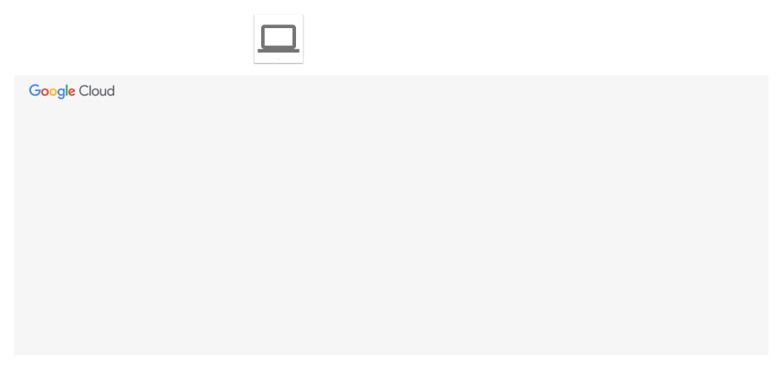
By the end of the lab, you will have used the architecture to perform several tasks.
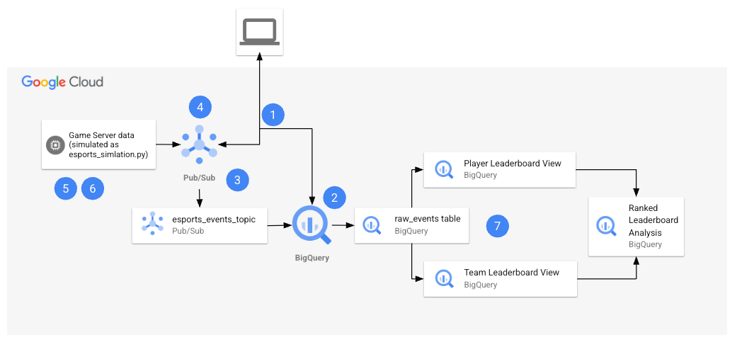
The following table provides a detailed explanation of each task in relation to the lab architecture.
Numbered Task | Detail
1. | Configure environment variables in Cloud Shell.
2. | Create the BigQuery resources:  You will use Cloud Shell commands to create the BigQuery dataset and table.
3. | Create the Pub/Sub Topic and Subscription:  You will use the Pub/Sub console to create the topic and subscription, and the modify the subscription so that it can write to your BigQuery dataset and table.
4. | Grant Pub/Sub IAM permissions:  You will use the IAM console to grant permissions to the compute service account.
5. | Retrieve the Python files from the repo:  In this task, you retrieve the Python file from the repo, and configure it for your project.
6. | Generate synthetic data  With the Python file configured for your project, you will then run the esports-simulation.py file, which uses Python to generate continuous Pub/Sub messages for game events.
7. | Verify the results in BigQuery:  Now that you have sent the data to your Pub/Sub topic, your data is being captured and stored in your BigQuery table. You will run queries on the table and use view analyze the results of the games.

Objectives
In this lab, you learn how to:
- Create the cloud resources and grant access to them.
- Retrieve Python file from the repo and modify it for your project.
- Generate synthetic data.
- Verify the player and team results in BigQuery.
Finally, you will have time to reflect on what you have learned in this lab and consider how you could address your own use cases with streaming data by answering questions in your Lab Journal.

Setup and requirements

Before you click the Start Lab button
Read these instructions. Labs are timed and you cannot pause them. The timer, which starts when you click Start Lab, shows how long Google Cloud resources are made available to you.
This hands-on lab lets you do the lab activities in a real cloud environment, not in a simulation or demo environment. It does so by giving you new, temporary credentials you use to sign in and access Google Cloud for the duration of the lab.
To complete this lab, you need:
- Access to a standard internet browser (Chrome browser recommended).
Note: Use an Incognito (recommended) or private browser window to run this lab. This prevents conflicts between your personal account and the student account, which may cause extra charges incurred to your personal account.
- Time to complete the lab—remember, once you start, you cannot pause a lab.
Note: Use only the student account for this lab. If you use a different Google Cloud account, you may incur charges to that account.

How to start your lab and sign in to the Google Cloud console
- Click the Start Lab button. If you need to pay for the lab, a dialog opens for you to select your payment method. On the left is the Lab Details pane with the following:
  - The Open Google Cloud console button
  - Time remaining
  - The temporary credentials that you must use for this lab
  - Other information, if needed, to step through this lab
- Click Open Google Cloud console (or right-click and select Open Link in Incognito Window if you are running the Chrome browser).
The lab spins up resources, and then opens another tab that shows the Sign in page.
Tip: Arrange the tabs in separate windows, side-by-side.
- Note: If you see the Choose an account dialog, click Use Another Account.
- If necessary, copy the Username below and paste it into the Sign in dialog.
- "Username"
- Copied!
- You can also find the Username in the Lab Details pane.
- Click Next.
- Copy the Password below and paste it into the Welcome dialog.
- "Password"
- Copied!
- You can also find the Password in the Lab Details pane.
- Click Next.
- Important: You must use the credentials the lab provides you. Do not use your Google Cloud account credentials.
- Note: Using your own Google Cloud account for this lab may incur extra charges.
- Click through the subsequent pages:
  - Accept the terms and conditions.
  - Do not add recovery options or two-factor authentication (because this is a temporary account).
  - Do not sign up for free trials.
After a few moments, the Google Cloud console opens in this tab.
Note: To access Google Cloud products and services, click the Navigation menu or type the service or product name in the Search field. 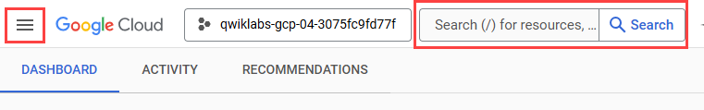

Task 1. Configure environment variables in Cloud Shell
In this task, you configure environment variables in Cloud Shell.
- Open Cloud Shell, by clicking Activate Cloud Shell.
- You need to Authorize use, as this is the first time you use Cloud Shell in this lab. To do this, click Continue and then Authorize in the pop-up windows.
- Run the following commands.
export PROJECT_ID="set at lab start"
- export BUCKET_NAME="set at lab start-bucket"
- Copied!
- Run the commands below to confirm the variables are stored.
echo ${PROJECT_ID}
- echo ${BUCKET_NAME}
- Copied!
- You will use these variables later in the lab.

Task 2. Create the BigQuery resources
In this task, you will create the Dataset and BigQuery table that will receive the raw streaming events from Pub/Sub.

Create the BigQuery dataset
In this task, you will create the BigQuery dataset that will act as a container for your tables and views.
- At the top of the Google Cloud console, use the search bar to find and navigate to BigQuery. The "Welcome..." pop-up window appears.
- Click Done.
- In the Explorer pane on the left, find and click on your project ID, which is set at lab start.
- Click the three vertical dots (⋮) to the right of your project ID to open the options menu, and then select Create dataset.
- On the Create dataset panel, configure the following settings:
  - Dataset ID: esports_analytics
  - Data location: Select a location from the dropdown menu. For this lab, US (multiple regions in United States) is a suitable choice.
- Leave the other settings as their default values and click CREATE DATASET. You see the new esports_analytics dataset appear under your project ID in the Explorer pane. This confirms you have successfully created the dataset.

Create the BigQuery table
- Within the Explorer pane, expand your project and select the esports_analytics dataset.
- Click the three vertical dots (⋮) next to the dataset name and select Create table.
- Configure the table with the following settings:
  - Table name: raw_events
  - Schema: Click Edit as text and provide the following JSON array.
[
{"name": "event_id", "type": "STRING", "mode": "NULLABLE"},
{"name": "match_id", "type": "STRING", "mode": "NULLABLE"},
{"name": "game_name", "type": "STRING", "mode": "NULLABLE"},
{"name": "event_type", "type": "STRING", "mode": "NULLABLE"},
{"name": "team_a_id", "type": "STRING", "mode": "NULLABLE"},
{"name": "player_a_id", "type": "STRING", "mode": "NULLABLE"},
{"name": "team_b_id", "type": "STRING", "mode": "NULLABLE"},
{"name": "player_b_id", "type": "STRING", "mode": "NULLABLE"},
{"name": "winner_player_id", "type": "STRING", "mode": "NULLABLE"},
{"name": "winner_team_id", "type": "STRING", "mode": "NULLABLE"},
{"name": "timestamp", "type": "TIMESTAMP", "mode": "NULLABLE"}
- ]
- Copied!
- Click Create table.
The result is the raw_events table is created in your the esports_analytics dataset.
Click Check my progress to verify the objective.
Create the BigQuery resources.

Task 3. Create the Pub/Sub Topic and Subscription
In this task, you create the Pub/Sub topic and subscription to receive the streaming game data, add IAM permissions and modify the subscription to allow applications to receive messages from that topic and direct these to the raw_events table in BigQuery.

Create the topic
- Navigate to Pub/Sub in the Google Cloud Console. You can use the top search bar to find it.
- At the top of the page, click + CREATE TOPIC.
- For the Topic ID, enter esports_events_topic.
- You see an option to Add a default subscription, keep this enabled.
- Leave all other settings as their default values.
- Click CREATE.
The result is the topic and the subscription are created.

Edit the subscription configuration and set IAM permissions
- In the list of subscriptions, click on esports_events_topic-sub.
- Click EDIT. You see the subscription options on the Edit supscription page.
- For Delivery type choose Write to BigQuery. You see more options appear.
- Choose esports_analytics for the dataset option.
- Enter raw_events for the table. Notice that an error is displayed like the one below:
- Service account: service-Project number@gcp-sa-pubsub.iam.gserviceaccount.com is missing permissions required to write to the BigQuery table: bigquery.tables.get, bigquery.tables.updateData.
- This means that you need to grant the proper permissions to the Pub/Sub service account to write to the raw events table. You will do that now.

Grant the Pub/Sub service account BigQuery table permissions
- Copy the service account email address from the error message.
- service-Project number@gcp-sa-pubsub.iam.gserviceaccount.com
- Navigate to BigQuery: Open the BigQuery page from the console in a new browser tab.
- Share the Dataset: In the Explorer panel, find your esports_analytics dataset, click the three vertical dots (⋮) next to it, and select Share and then Manage Permissions.
- Add the Principal: In the Dataset permissions panel that appears, click Add principal.
- Paste the full Pub/Sub service account email (from step 1) into the New principals field and use the tab key to complete it.
- For the Role, select BigQuery Data Editor.
- Click Save.
Your BigQuery subscription is now authorized to write incoming messages directly into the raw_events table.

Complete the modifications to the Pub/Sub subscription
- Return the browser tab with Pub/Sub.
- For Schema Configuration, choose Use table schema.
- Keep the remaining options using their defaults.
- Click UPDATE.
The subscription configuration is now saved and the with the subscription now properly configured, Pub/Sub will direct all messages (the streaming e-sports data) to your raw_events table in BigQuery.
Click Check my progress to verify the objective.
Create the Pub/Sub topic and subscription.

Task 4. Grant Pub/Sub IAM Permissions
To ensure your solution runs smoothly, you also need to grant Permission for the compute service account to publish messages to the Pub/Sub topic.
This allows your Python script or application to send messages to the Pub/Sub topic.
- In the Google Cloud Console, navigate to IAM & Admin > IAM. You see the list of principals currently configured with permissions.
- Find the principal with the email address Project number-compute@developer.gserviceaccount.com.
- Edit the roles for this principal: Click the Edit Principal. You see the Edit access panel open for the principal and the editor role is included.
- Click + Add another role
- In the Select a role field, search for and select the Pub/Sub Publisher role.
- Click Save.
The role is now assigned to the compute principal.
Click Check my progress to verify the objective.
Grant Pub/Sub IAM permissions.

Task 5. Retrieve the Python files and configure them.
In this task you use wget in Cloud Shell to retrieve the Python file from a public Cloud Storage bucket. Once retrieved you will open the file in Cloud Shell Editor and use the Code Assist feature of Gemini to explain how the file works. Finally, you will use the Cloud Shell Editor to configure the file with details for your project.

Retrieve the Python files
- Return to Cloud Shell.
- Run the following command to return to the home directory.
- cd ~
- Copied!
- Create the esports directory and navigate to it.
mkdir esports
- cd esports
- Copied!
- Retrive the Python file using the wget commands below.
- wget https://storage.googleapis.com/spls/gsp1342/esports-simulation.py
- Copied!
- You see confirmation in the terminal that the files are downloaded.

Use code assist to explain what Python file does
- Click on the Open Editor button in Cloud Shell. You see the Cloud Shell Editor open. You also see the Gemini Code Assist pane.
- Close the Walkthrough tab.
- In the Explorer pane, expand the esports folder. You see the Python files displayed.
- Open the esports-simulation.py file.
- Within the Gemini Code Assist pane, at the bottom you see a place to enter a prompt, where it says "Ask Gemini." Enter the following prompt:
- Review the code in the file esports-simulation.py. Explain what this code does.
- Copied!
You see that Code Assist explains what the code does in detail. At a high level the code will simulate an e-sports match of events and publishes these to a Google Cloud Pub/Sub topic.
You may see that Code Assist has made some suggestions for improvement. Do not accept the suggestions.

Time to reflect
- Considering your data and use cases, think of how you would use Python to generate synthetic data or collect data from your applications, and then publish this data as a Pub/Sub topic in your own development workflow.
Note: Gemini was used to assist the developer who created the esports-simulation.py file. Consider using Gemini to generate synthetic streaming data with Python for your projects, and help explain and troubleshoot your code with Code Assist.
- Considering your data and use cases, think about how you would use Pub/Sub, then store and analyze streamed data from Pub/Sub in BigQuery.

Configure the file for your project
- Around line 10, set the PROJECT_ID variable to your Project_ID, as with the other file simply replace the line with the code below.
- PROJECT_ID = "set at lab start"
- Copied!
- Note: If you do not modify the files for your project you will encounter errors at runtime in the Cloud Shell when you run these files in the next task.
- Save the file.

Task 6. Generate synthetic data
In this task you will run the Python files to generate the synthetic data and run the pipeline.

Install the dependencies and run the simulator
- Return to Cloud Shell terminal.
- Confirm you are in the home directory.
- cd ~
- Copied!
- Navigate to the esports directory.
- cd esports
- Copied!
- Use pip to install the dependencies, specifically the Python library for Pub/Sub.
- pip install google-cloud-pubsub
- Copied!
- Run the simulator. This script will run continuously, sending events to your Pub/Sub topic.
- python3 esports-simulation.py
- Copied!
- You will see output indicating that events are being published within the terminal.
- Important: Keep this terminal open and running.

Task 7. Verify the results in BigQuery
In this task you will confirm the raw_events table is updated with new messages from the Pub/Sub subscription. First, you will query the raw_events table. Then you will create two views, and then query the views to display the player and team leaderboards. You will also take time to reflect on how Looker could be used to enhance the leaderboard visualizations.

Query the raw_events table
- Return to BigQuery.
- In the explorer panel, find and select the raw_events table.
- Click Query. A template query is provided to you.
- Modify this query by selecting all records in the raw_events table, by using the query below:
- SELECT * FROM `set at lab start.esports_analytics.raw_events` LIMIT 1000
- Copied!
- Run the query. If you see records displayed, this means that Pub/Sub is updating the table with the latest messages (e-sports game data) from the simulation.

Create the views in BigQuery
- In the explorer, expand your project and select the esports_analytics dataset.
- Click the plus to create a new query.
- In the query tab provided, enter the following query.
-- Query 1: Create the Player Leaderboard View
-- This view calculates player scores from raw events and ranks them.

CREATE OR REPLACE VIEW `esports_analytics.player_leaderboard_live` AS
SELECT
RANK() OVER (ORDER BY SUM(CASE WHEN event_type = 'match_end' THEN 5 ELSE 1 END) DESC) as rank,
winner_player_id AS player_id,
SUM(CASE WHEN event_type = 'match_end' THEN 5 ELSE 1 END) AS total_score,
MAX(timestamp) AS last_updated
FROM
`set at lab start.esports_analytics.raw_events`
WHERE
winner_player_id IS NOT NULL
AND (event_type = 'player_elimination' OR event_type = 'match_end')
GROUP BY
winner_player_id;

-- Query 2: Create the Team Leaderboard View
-- This view calculates team wins from raw events and ranks them.

CREATE OR REPLACE VIEW `esports_analytics.team_leaderboard_live` AS
SELECT
RANK() OVER (ORDER BY COUNT(*) DESC) as rank,
winner_team_id AS team_id,
COUNT(*) AS total_wins,
MAX(timestamp) AS last_updated
FROM
`set at lab start.esports_analytics.raw_events`
WHERE
winner_team_id IS NOT NULL
AND event_type = 'match_end'
GROUP BY
- winner_team_id;
- Copied!
- Note: The queries above are already templated for your project. If you were running this in your own project, you would need to replace set at lab start with your actual Project ID.
- This query creates two views one for the player leaderboard and the other for the team leaderboard. It will find the most recent scores for the player and the team, and rank them accordingly.

Run a query to display the player leaderboard
- Click the plus to create a new query.
- In the query tab provided, enter the following query.
- SELECT * FROM `esports_analytics.player_leaderboard_live` ORDER BY rank;
- Copied!
- The result is the player leader board is displayed with the players ranked, in order from first to twelth place based upon total wins.

Run a query to display the team leaderboard
- Click the plus to create a new query.
- In the query tab provided, enter the following query.
- SELECT * FROM `esports_analytics.team_leaderboard_live` ORDER BY rank;
- Copied!
- The result is the teams are ranked in order from first to fourth place based upon total wins.

Time to reflect
Consider the results you found in BigQuery. This lab only used leaderboards based upon SQL queries in BigQuery. Think about how you could build a dashboard for these leaderboards in Looker and answer the following questions using your lab journal:
- What would the dashboard look like?
- Which existing BigQuery queries would you leverage?
- Who would need access to the dashboard?
- Do you need to modify the queries in any way to keep the Looker dashboard up to date?
Click Check my progress to verify the objective.
Verify the results in BigQuery.

Congratulations!
You used a Python script to simulate game data. You also used Cloud Assist to help you explain the code in these scripts. Finally, you have generated Google Cloud resources to support your esports streaming data, including a Pub/Sub topic and subscription, a BigQuery Dataset, tables and views, to stream this data and generate reports on which players and teams are in the lead. You are becoming more confident with Google Cloud each day and can use Gemini to supplement your knowledge and skills with Data Engineering workflows.

Next steps / learn more
- Generate a SQL query
- Explain SQL queries
- Gemini Models
- Generative AI
- Write better prompts for Gemini for Google Cloud

Google Cloud training and certification
...helps you make the most of Google Cloud technologies. Our classes include technical skills and best practices to help you get up to speed quickly and continue your learning journey. We offer fundamental to advanced level training, with on-demand, live, and virtual options to suit your busy schedule. Certifications help you validate and prove your skill and expertise in Google Cloud technologies.
Manual last updated on August 6, 2025
Lab last tested on August 6, 2025
Copyright 2025 Google LLC. All rights reserved. Google and the Google logo are trademarks of Google LLC. All other company and product names may be trademarks of the respective companies with which they are associated.

